HR RECRUITMENT ANALYTIC PROJECT

Prepared by : Vanshika Singh Date : June 2026
Table of Contents

- Introduction
- Project Objectives
- Dataset Description
- Tools and Technologies
- Data Cleaning
- SQL Analysis
- Dashboard and Visualizations
- Key Insights
- Recommendations
- Conclusion

Introduction
This Recruitment Analytics project analyzes candidate and hiring data to evaluate recruitment performance and identify key hiring trends. Using SQL, Excel, and Power BI, the dashboard provides insights into hiring rates, candidate profiles, interview outcomes, and recruitment strategies, enabling HR teams to make informed, data-driven hiring decisions efficiently.

Project Objective
The objective of this Recruitment Analytics project is to analyze recruitment data and evaluate the effectiveness of the hiring process. The project aims to identify factors influencing hiring decisions, measure key recruitment metrics, and uncover trends related to candidate demographics, experience, and assessment scores. The insights generated help HR professionals optimize recruitment strategies and improve hiring outcomes.

Data Description

- Total Records: 1,500 candidate applications analyzed.
- Candidate Demographics: Age and Gender information.
- Educational Background: Candidate qualification levels.
- Professional Experience: Years of experience and previous companies worked.
- Location Factor: Distance between candidate and company.
- Assessment Metrics: Interview Score, Skill Score, and Personality Score.
- Recruitment Channels: Different recruitment strategies used for sourcing candidates.
- Hiring Outcome: Final hiring decision (Hired/Not Hired).
- Data Purpose: To identify hiring trends and evaluate recruitment effectiveness.
- Business Value: Supports data-driven recruitment and talent acquisition decisions.
TOOLS AND TECHNOLOGIES

Tools Purpose
PostgreSQL Data Analysis
SQL Querying
Power BI Dashboard
Excel Data Review

Data Cleaning

- Checking of null value

- Checking for duplicate records

- Checking of invalid Values

- Checking unique categories

- Checking of Data types

SQL ANALYSIS

- Total Candidates Analysis :

SELECT COUNT(*) AS Total_Candidates
FROM Candidate_data;

- Result :

Total Candidates = 1500

- Total Candidates Hired Analysis :

SELECT COUNT(*) AS Total_Hired
FROM Candidate_data
WHERE HiringDecision = 1;

- Result :

Total Hired Candidates = 465

- Overall Hiring Rate :
SELECT
ROUND(
COUNT(CASE WHEN HiringDecision = '1' THEN 1 END) * 100.0
/ COUNT(*),2
) AS Hiring_Rate
FROM Candidate_data;

- Result :

Hiring rate = 31.0%

- Average Candidate Experience Analysis :
SELECT ROUND (AVG(ExperienceYears), 2) AS
Avg_Experience
FROM Candidate_data;

- Result :

Average Candidates Experience Analaysis = 7.69

- Average Interview Score Analysis :
SELECT ROUND(AVG(InterviewScore),2) AS
Avg_Interview_Score
FROM Candidate_data;

- Result :

Average Interview Score Analysis = 50.59

- Gender-wise Hiring Rate Analysis :
SELECT
Gender,
COUNT(CASE WHEN HiringDecision= '1'
THEN 1 END) AS Hired_Count
FROM Candidate_data
GROUP BY Gender;

- Result :

Gender- Wise Hiring Rate = Female = 228, Male = 237

- Hiring Rate by Interview Score Range Analysis :

SELECT
CASE
WHEN InterviewScore <50 THEN
'Below 50'
WHEN InterviewScore Between 50 AND
69 THEN '50-69'
WHEN InterviewScore Between 70 AND
84 THEN '70-84'
ELSE '85+'
END AS Score_Range,
ROUND(
COUNT(CASE WHEN HiringDecision = '1' THEN 1 END) *100.0
/COUNT(*),2
) AS Hiring_Rate
FROM Candidate_data
GROUP BY Score_Range
ORDER BY Score_Range;

- Result :

Score Range | Hiring Rate
50-69 | 23.43
70-84 | 40.68
85+ | 47.25
Below 50 | 25.70

Dashboard

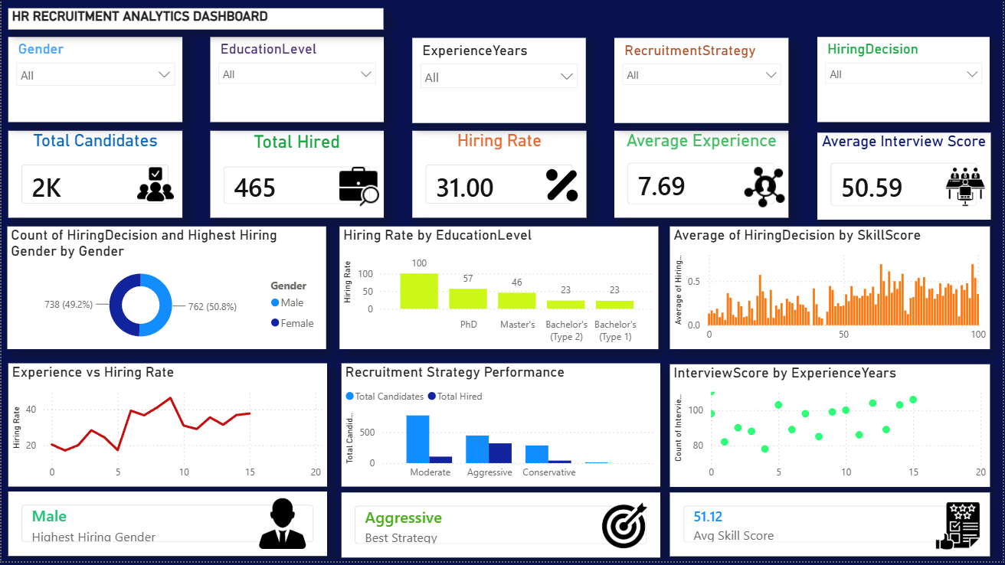

Key Insights
1. Overall Hiring Performance
- Out of approximately 2,000 candidates, 465 candidates were hired.
- The overall Hiring Rate is 31%, indicating a selective recruitment process.
2. Gender-wise Hiring Distribution
- Male candidates account for a slightly higher share of hires (50.8%) compared to female candidates (49.2%).
- Gender hiring distribution is relatively balanced.
3. Education Level Impact
- Candidates with PhD qualifications show the highest hiring rate.
- Hiring probability decreases for candidates with lower educational qualifications.
4. Experience Influences Hiring
- Hiring rate generally increases with candidate experience.
- Candidates with 8–10 years of experience demonstrate the strongest hiring outcomes.
5. Recruitment Strategy Effectiveness
- The Aggressive Recruitment Strategy generated the highest number of hires.
- Conservative recruitment approaches resulted in significantly fewer successful hires.
6. Skill Score and Hiring Relationship
- Higher skill scores are associated with a greater likelihood of selection.
- Candidates with strong technical and professional skills have a competitive advantage.
7. Interview Performance Matters
- Candidates with better interview scores are hired more frequently.
- Interview assessment is a critical factor in final hiring decisions.

Recommendations
1. Focus on High-Performing Recruitment Channels
- Increase investment in aggressive recruitment strategies since they generate the highest number of successful hires.
2. Prioritize Skilled Candidates
- Implement stronger screening mechanisms to identify candidates with higher skill scores early in the recruitment process.
3. Strengthen Interview Evaluation
- Standardize interview processes and interviewer training to improve hiring accuracy and consistency.
4. Develop Talent Pipelines for Experienced Candidates
- Create targeted recruitment campaigns for candidates with mid-to-high experience levels, as they demonstrate better hiring success.
5. Maintain Gender Diversity
- Continue promoting equal opportunity hiring practices to sustain balanced gender representation.
6. Education-Based Recruitment Planning
- For specialized roles, prioritize candidates with advanced educational qualifications while maintaining role-specific requirements.
7. Use Data-Driven Recruitment Decisions
- Continuously monitor hiring metrics, interview scores, skill assessments, and recruitment strategies through HR dashboards to improve hiring efficiency.

Conclusion :
The HR Recruitment Analytics Dashboard provides valuable insights into hiring trends, candidate qualifications, recruitment strategies, and selection outcomes. Analysis shows that education level, experience, skill score, and interview performance significantly influence hiring decisions. Data-driven recruitment practices can improve hiring efficiency, talent quality, and overall organizational performance.

